**MULTI-PURPOSE CHAIR**

* Working cum Realxing Chair for Everyone

**Names**- Ankit kumar Pandey and Ashis Srivastava

**College**- NIT Durgapur

**Team ID**- 3774196

**Team Name**- FIJI

**INTRODUTION**

In the first few weeks of coronavirus outbreak in the world, products like protective masks, hand sanitiser, and even toilet paper, were flying off the shelves of both physical and online stores. But as the world started to impose lockdowns and transitioned to working from home, there was another thing people began to frantically [search](https://gearpatrol.com/2020/04/01/desk-office-chairs-ergonomics-sales-surge/) the depths of the internet to buy for their homes–A perfect chair.

**ABSTRACT**

This Document presents the solution ideas proposed by team FIJI for CADEMICS 2020. The design of the Multipurpose chair is discussed below in details.

**1. Design Detail of Multi-Purpose Chair.**

Multipurpose chair which serves both the function of comfort and innovation is designed by our team. The chair is controlled not only by physical movement but can be controlled by the help of remote as it has a Microcontroller unit embedded in it.Omni wheel drive is selected for better mobility. The Overall dimensions are height of 38.75”-41.75” (98-106 cm), width of 23” (58 cm), and depth of 23” (58 cm).Total Estimated weight is around 20Kg.

**1.1 Drive Selection:**

The movement of our Multipurpose chair is accomplished by holonomic control of four wheeled omni directional drive. Omnidirectional wheels have become popular for mobile robots, as they allow the bot to move on a straight path from a dead stop, without having to rotate prior. Moreover, translational motion along any desired path can be combined with rotation, so the robot arrives at its destination at desired angle (orientation). Double aluminium 152mm omni directional wheels are to be assembled on a base frame made up of T-slotted 4040 aluminium extrusion channels (as these extrusion channels offers ease of assembly and convenient installation) in a 45-degree cross configuration, to get a resultant torque of about [(2.81~2.83)T], where “T” is the Torque generated by a single DC Motor. Since the team aims to achieve movement of the chair from one place to other in minimum possible time, so accordingly the DC motor variables were calculated which depends on factors like number of wheels, dimension of wheels, weight of the robot, traction of the wheels. Weight of robot is estimated to be 17.3kgs and traction between wheel and the arena plyboard surface is in the range of 0.65~0.75. Using these values, min torque and rpm calculations is done and as a result a HD Planetary DC geared 468rpm 24V 72.6N-cm Motor is selected as the main driving motors.

**1.2 Features Incorporated**

1.Remote Control.

2.Desk for work.

3.Charging Socket.

4.Laptop/books Tray.

5.Bottle/Drinks Container.

6.Comfort(zero gravity +Pressure Relief)

7.Work cum Relax Foldable Chair.

**Steps Followed /Workflow:**

Worked in both part design and surface design workbenches.Though we faced a lot of difficulties in surface design workbench while taking the arbitrary points for making our spline yet we enjoyed a lot in this task and came to know about many tools which we did not knew it exists.We designed our base frame in part design workbench only there we used mainly pad,pocket,rib,stiffner,etc. The cushions was made mainly in surface design workbench involving splines,edge fillet,multisection surface,join,fill,extrusion,sweep,blend,etc and some more.

After that we made some Ascessories such as Charging socket,book /laptop tray, A revoving desk,We then planned to widen our chair to a new dimension by making it a sleep cum work chair for which we designed a relaxing cushion adjusted by a knob and a suspension at back for proper comfort.

The design was ready over here then came the task of some simulations.We entered into DMU Kinematics and did simulations on following-

1.Up and down/ Revolving about an axis controlled by knobs

2.On Adjusting tray-to revolve and rotate about some axis.

3.Change from working chair to relaxing chair.

***CAD DESIGN SCREENSHOTS***

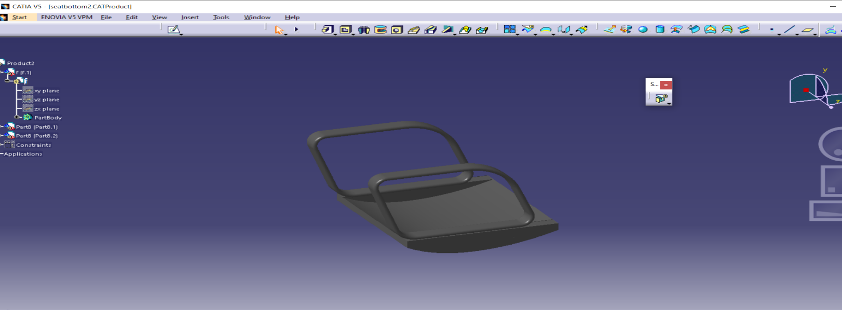

*FIG-1:BOTTOM SEAT COVER*

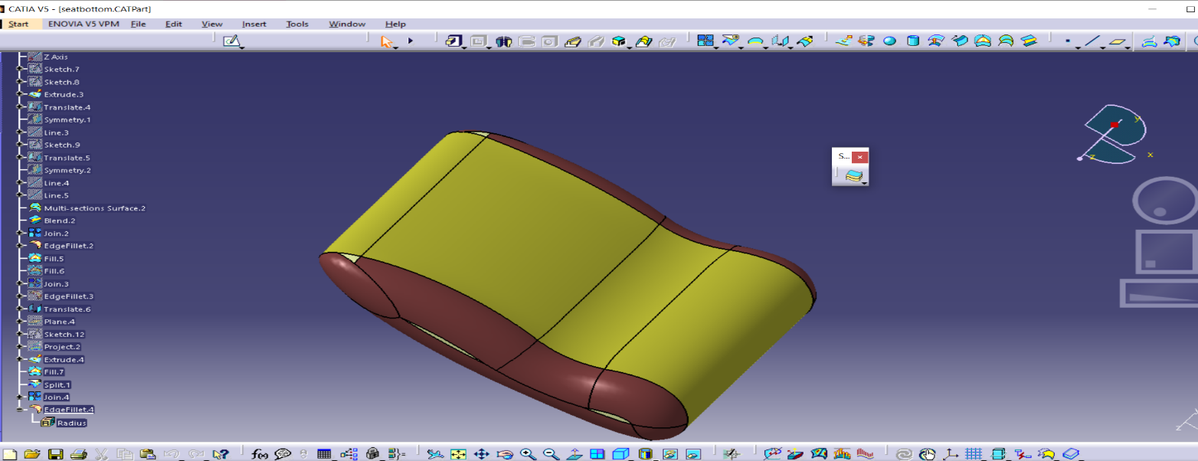

*FIG-2: BOTTOM SEAT*

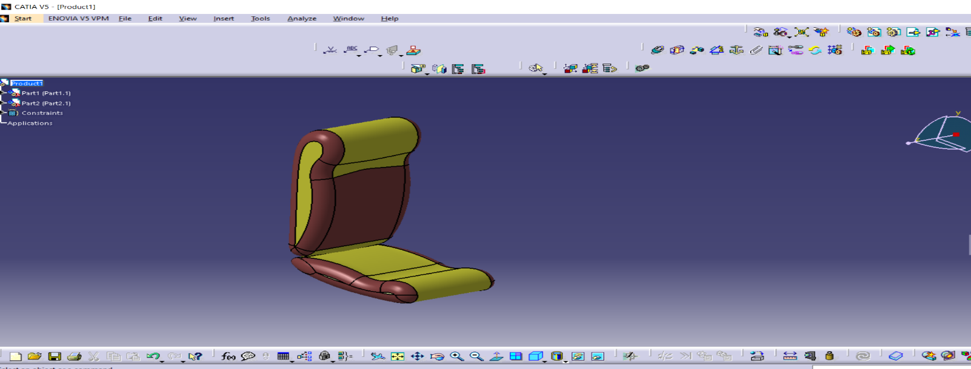

*FIG-2: SEATS ASSEMBLED*

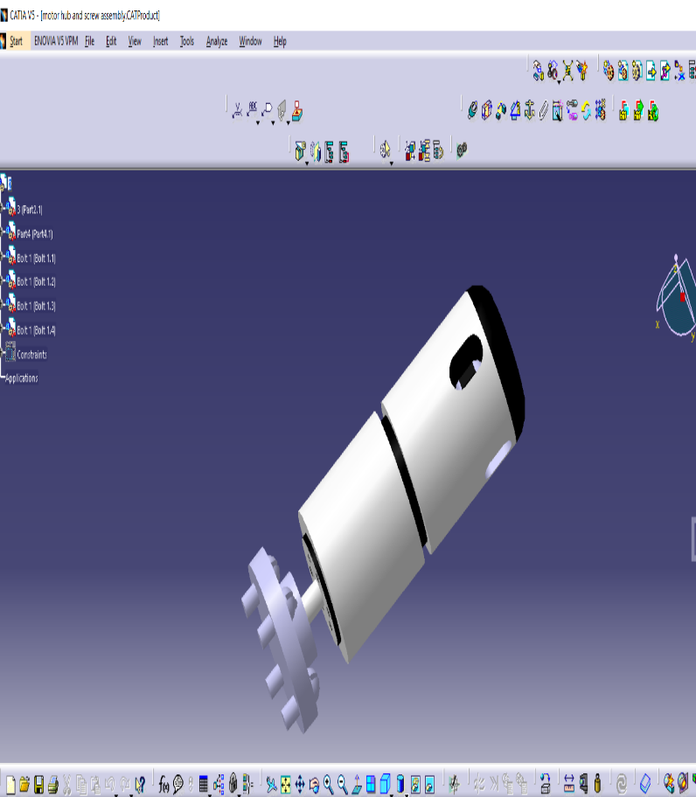 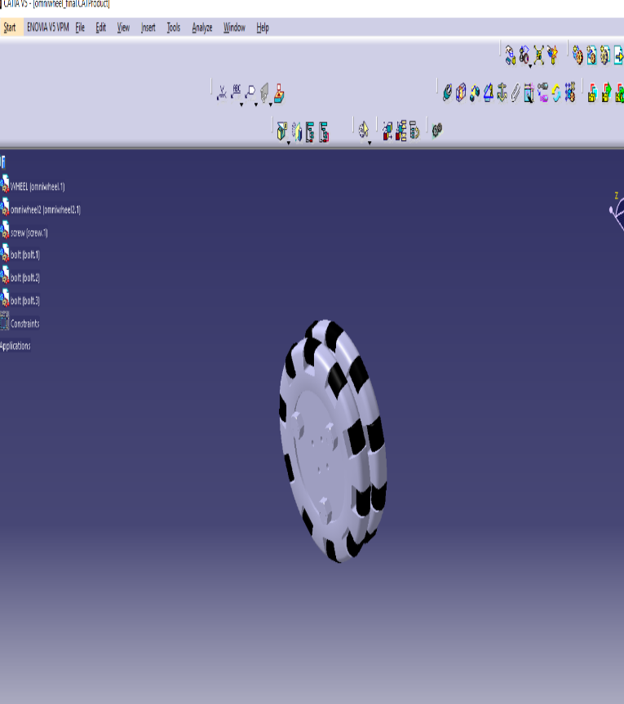

*FIG-OMNI WHEEL AND MOTOR*

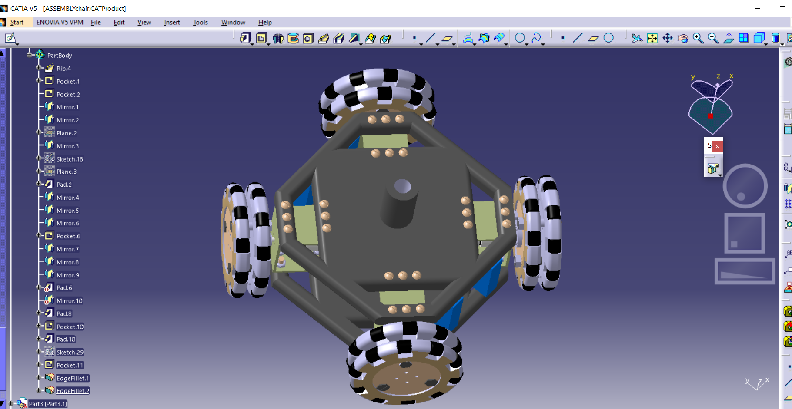

*FIG-BOTTOM BASE (Omni wheels aligned at 45 degrees)*

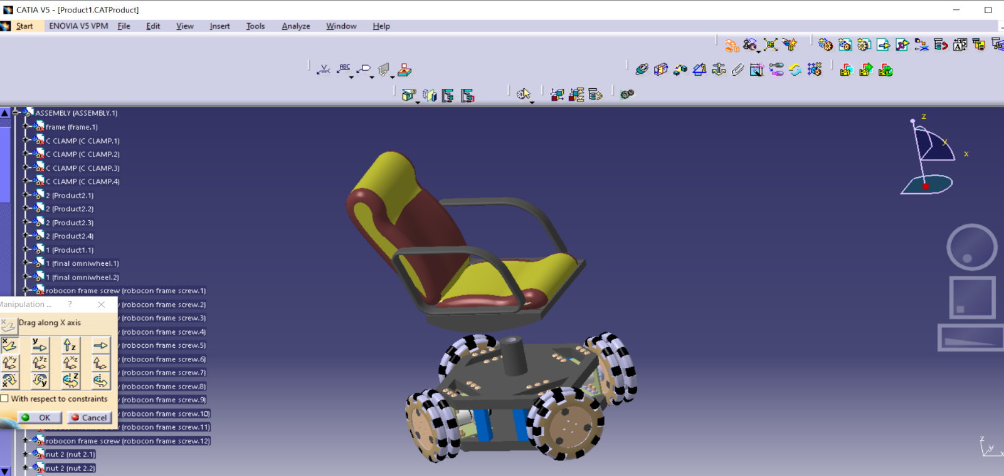

*FIG-ASSEMBLING TOP WITH BOTTOM*

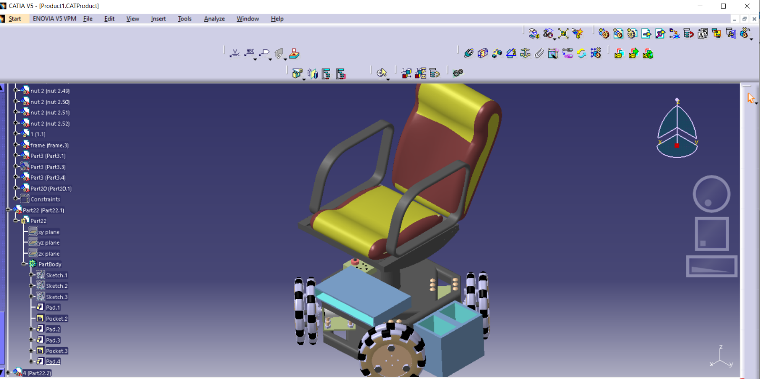

*FIG-LAPTOP/BOOK CASE AND BOTTLE CONTAINER AND CHARGING SOCKET.*

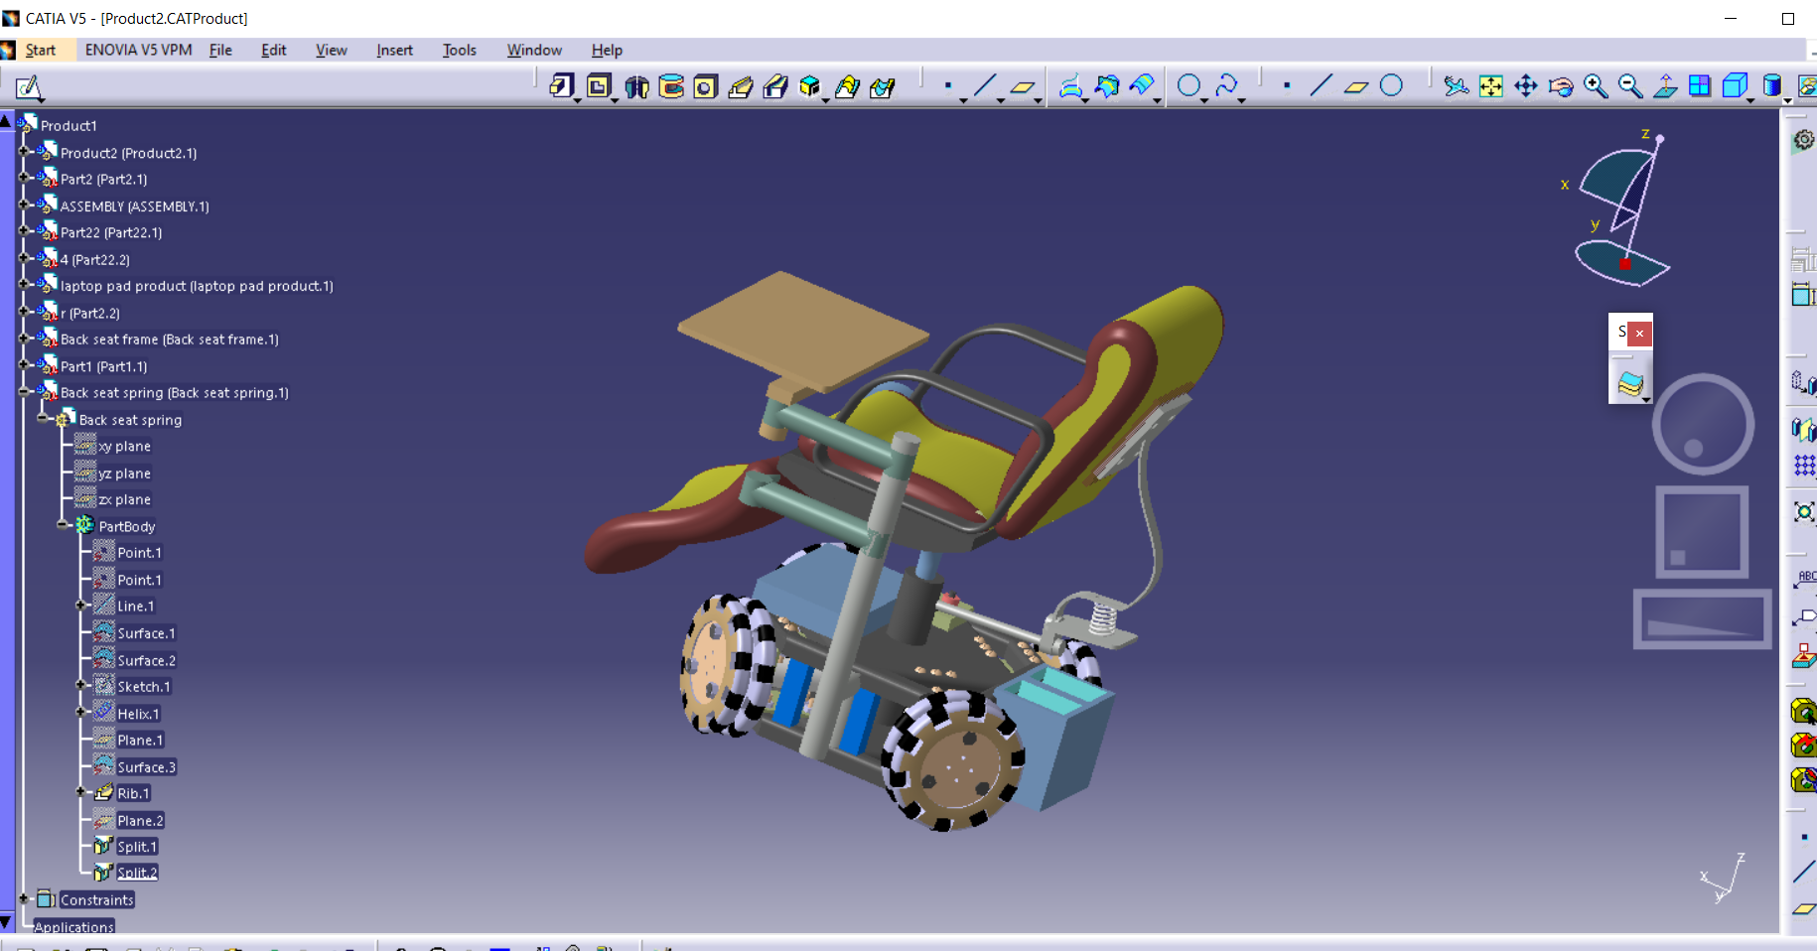

*FIG-2 DOF ADJUSTABLE DESK (Revolve about verical column and rotate about horizontal axis)*

**

*FIG-Foldable Working cum Sleeping Option*

***FINAL ASSEMBLY***

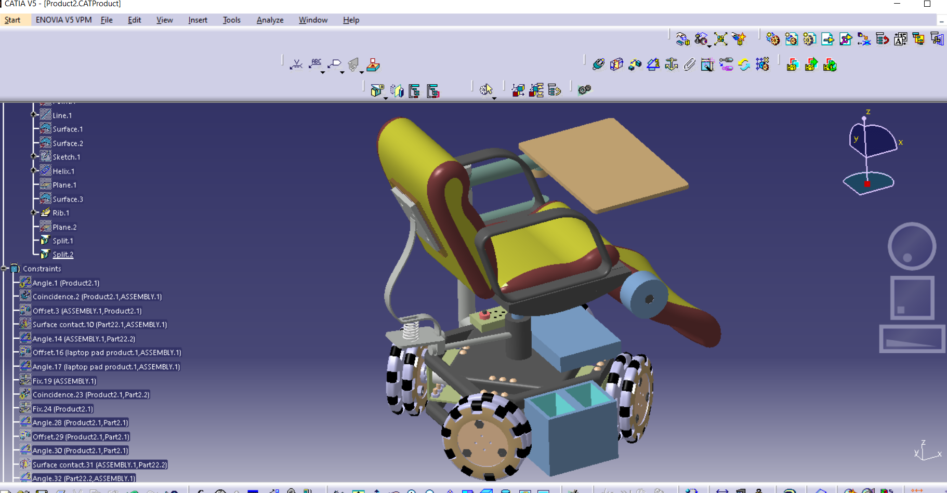

***FIG-RIGHT VIEW***

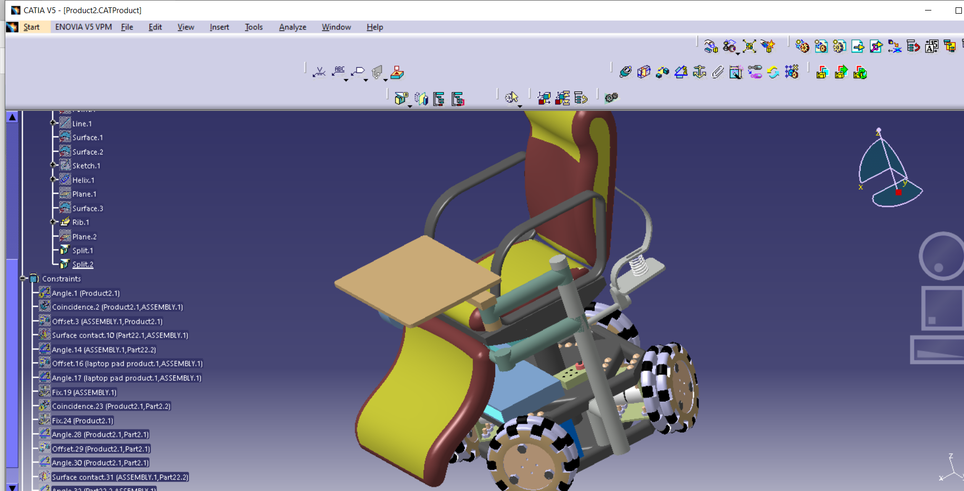

***FIG-LEFT VIEW***